

**AGM Wednesday 8th May, 2024 @ 7.00 pm**

**Venue**: “San Clu” Hotel, Ramsgate

**Committee Present:** Chairperson: Pete Heath;  Men’s Captain: Andy Stevens, Women’s Captain: Jo Kemp; Club Secretary, Julie Williams;  Safeguarding & Welfare: Ade Neaves, Julie Neaves; Social Secretaries: Janice Lee Miller, Janet Morgan, Treasurer: Simon Cowdery, Vice-Chair: Kev Bullions, President: Derek Sackett

**Club Members:** See attendance list on last page.

**Apologies Received From:** Communications: Jon Holl; Membership Secretary: Jo Holl, Nikki Boyes, Claire Greenaway, Tim Greenaway, Sam Hastie, Andy Jones.

**Minutes**

**1. Chairperson’s Review:**

Pete extended a warm welcome to everyone, there was a great turn-out, all the extra chairs were needed. As an important update and with mixed feelings, Pete Heath noted that Derek Sackett was standing down as President after being part of this club from day 1 and after giving many years of service to the club. While we are very sad at the retirement of Derek from this role, we are glad that he is now able to take more time with his family. *See later in the Minutes for more on our thanks and photos*. Pete noted that with this retirement, the committee has decided to retire the role of President, as this is not a required role by EA. This involves a change to the club constitution which was discussed and voted on later in the meeting.

This year, the club is also having a key change with the new collaboration with Sporting Events for club races. This decision was taken to secure the future running of races, as it was becoming increasingly difficult to put on races with the pre-race set up activities, race director responsibilities and post race clearing of signs etc.

The races planned are still Thanet Roadrunners races and enable us to keep slots on the racing calendar. Pete also noted that we have a three year contract, and we can choose to stop, amend or carry on after that time, depending on how it goes.

Membership numbers are growing again, which is great. A lot of the expanding numbers are due to Couch to 5K, which while a team effort, is very much due to the efforts of Jon Holl, ably assisted by stalwart members of the club during many dark and wet evenings in early months of the year.

Pete also extended a sincere well done to Janet and Janice for their efforts in organising the club social events. The Christmas party was sold out, quiz nights have been a huge success, brilliantly supported by our quiz master of Tipping Point fame, Kev Bullions. These have raised over £700 to date for charity, this year our chosen charity being the Pilgrim’s Hospice. Summer runs and BBQ are getting closer and more details were shared later.

Pete also noted that he is standing down from the Chair role this year and wanted to take the opportunity to thank all committee members, both past and present for their great support. In particular, it has been great to have Simon in place as Treasurer and also to see the uplift in social media communications through the efforts of Jon. Pete noted that the committee both past and present has been and is a very strong team and he is leaving the role in very good hands.

**2. Membership Update:**

In Jo Holl’s absence, Julie Neaves was able to confirm that at present we have 174 members including 6 juniors and 87 are EA affiliated.

**3. Safeguarding & Welfare Report**

Julie and Ade have been welfare officers for the club for 2 years, attending the monthly committee meetings to ensure that welfare is a consideration always in the running of the club. Safety on club runs is always a key topic. The welfare officers and run leaders have recently discussed the use of headphones including bone conducting headphones. Each run is risk assessed. We encourage people not to wear headphones, even if bone conducting, particularly on hill runs, where a section is on the road. If anyone has any issues or concerns during a run or outside of a run, everyone is encouraged to speak to one of them.

Julie noted that social events give a great chance to talk to and support other members of the club and we have been incorporating social opportunities after hills in summer and after the Sunday morning long run.

Julie invited any questions to be raised. Pam Philpot took the chance to highlight for attendees that while the welfare role can be a bit unseen, it is highly important and if this role is not in place and done correctly, a club cannot operate.

**4. Treasurer’s Report**

Simon was pleased to be able to provide a more formal report this year on the club finances, which is a requirement of EA. Several copies of the report were made available and are shared with the minutes.

This year, we were able to make a positive/surplus compared to forecast – due to 1) kit sales 2) better performance of races than predicted and 3) lower/lack of lighting fees at the track. Overall, we generated a £4,900 surplus.

This year approximately £1,600 was paid to charity.

Our major income is generated from membership, with a small amount from kit. It was noted that we are currently holding quite a lot of stock, which will help our income if we don’t have to purchase much kit in 2024-5.

The main cost to the club is hire of Royal Academy hall / running track.

In terms of the budget for 2024-2025 – there is some uncertainty about income from races with the new partnership with Sporting Events, how much kit will sell and whether we will have the track lighting costs. We have a request for purchase of a new marquee – as the current one is not strong enough to withstand the weather at cross country events. This would need to come out of the reserves.

EA also requires that clubs hold sufficient money in reserves to safeguard the club against challenging times, so our Treasurer would be hesitant to reduce the reserves significantly.

It was noted that in 2024-2025, we may plan a deficit to fund these additional items (e.g. marquee).

**5. Membership fees for 2025-2026**

Julie Williams explained that the committee needed to propose the membership fees for 2025-2026 at the AGM, for agreement from members present. This enables the club to charge up to this amount the following membership year. Depending on the financial situation at that time, the committee could choose to charge lower membership fees, but could not charge any higher than that agreed at the AGM.

The committee proposes that membership fees for 2025 can increase from £20 to £25 for adults (20% increase) and will remain at £15 for juniors, retirees and students. Asking for a show of hands to support this increase, the large majority of the room supported the proposal. A few members suggested that even £30 would have been acceptable and would enable more flexibility if required next year. Other comments were that should we decide to raise membership to a higher figure, it would be preferable to do that in steps. The committee thanked everyone for the input and comments and confirmed the proposal to have fees of up to £25 for adults and £15 for the other member categories.

**6. Captains Reports**

Andy Stevens discussed the Club champs and the role of the club captains.

65 members took part in the Club Champs, 46 males and 19 females. Pleasingly there was a sea of blue vests at races further afield eg Tenterden, which turned out to be a blazingly hot day. Andy commented that this is a sign of a very strong club. The Chislehurst half marathon was the same in terms of the size and strength of the team racing. We have aligned club champs races with the Kent Grand Prix and while TRAC is not one of the big clubs in terms of the membership numbers, we take more than our fair share of prizes. It was particularly pleasing to hear the chatter from Tunbridge Wells (akin to the Man city of running clubs) talk about how many points Thanet were earning.

Overall, only one or two points separated the winners of the Club Champs, showing how competitive this was. Andy extended massive thanks to Chris and Nikki for the incredible work done in their roles as club captains.

Andy commented that the role of club captain is the best role in the club! But with that comes great responsibility to lead by example – in terms of how we run, train, rest and talk about races. Importantly, how we as runners deal with success and setbacks. Andy noted (also from recent experience with a pothole in Milton Keynes) the margin between achieving your goal and not achieving it can be wafer thin. The role of club captain is to organise and keep a tally of scores. And importantly, to be your friendly supportive ear. If you want advice with anything related to running, please talk to the captains. If you are proud of your achievements, please shout about it, write a race report, similarly if you are disappointed with your running, do the same. We are always happy to listen, help and celebrate - it's all part of the job of club captain.

Jo covered the Kent Grand Prix and cross country. She extended many thanks for all the support and camaraderie which makes for a great team event out. Last season, 43 teams in Kent took part, TRAC finished 2nd (men’s) and 3rd (women’s) which was the first season that both the men and the women’s teams were both in the top 3. In addition, 7 TRAC runners were placed in their age categories, again a great achievement.

The men’s team is currently 4th and the women’s team is in 5th place, which is slightly ahead of this time last year. Our teams tended to score more highly in the races further afield from London and scheduled later in the year, so if we can have a strong turnout to the remaining races, we are hopeful of getting in top 3 again.

Cross Country season comprises 7 races in Kent. Matt McCarthy, Phil Stevens and Chris Brenchley led the men’s team. Jo Kemp, Brittany Crombie and Claire Greenaway led the women’s team. Our race at Minnis bay was very successful – thanks to Julie Williams as Race Director and all the marshals. Jo encouraged anyone to come forward and have a chat about the reality of cross country and mud 🙂 (it isn’t as bad as you might imagine!) if anyone is interested.

**Relays:**

A question was raised about the current status of the relays. The relays didn’t happen last year as the event had grown too large and questions were raised about the best approach. A lead from another club who was trying to reorganise the events had to stand down due to personal reasons and since then other clubs’ representatives have been trying to move the topic forward. Pete has been representing TRAC. There are some differing views on level of licensing, medical cover etc needed. We noted that we would not be able to get Thanet council approval in the short time remaining and have informed the other clubs that we are not able to host this year and would not be participating. Other clubs may be trying to finalise a few events. We would like to work with them and support re-establishing relays and propose clubs should partner in autumn of 2024, to ensure there is enough time to explore and apply for any necessary applications.

**7. Election of Club Executive Committee for the Period May 2024 to May 2025**

In accordance with the Club’s constitution, all of the Executive Committee roles are vacated each year and are open for election. A number of the current incumbents were willing to stand to be elected for a further year and there were members who were willing to stand for new roles. All TRAC members interested in standing for the committee were encouraged to stand and for every role, a vote was taken.

|  |  |  |  |
| --- | --- | --- | --- |
| **Elected Committee Roles** | **Elected 2024** | **Proposed** | **Seconded** |
| Chairperson | Julie Neaves | Julie Williams | Kev Bullions |
| Vice Chair | Simon Clayton | Kev Bullions | Derek Sackett |
| Treasurer | Simon Cowdery | Pete Heath | Julie Williams |
| Club secretary | Julie Williams | Ade Neaves | Anna Harrison |
| Membership secretary | Jo Holl | Simon Cowdery | Pete Heath |
| Men’s Captain | Andy Stevens | Julie Williams | Derek Sackett |
| Women’s Captain | Jo Kemp | Julie Neaves | Ade Neaves |
| Welfare Officer (*lead) | Ade Neaves*  Kirsty McMahon | Pete Heath  Janet Morgan | Ian Lockyer  Kev Bullions |
| Publicity Manager | Jon Holl | Derek Sackett | Simon Cowdery |
| President | *Committee propose to retire this role, with amendment to club constitution* |  |  |

Note: Ladies Captain has been supported by a Vice Captain: Brittany Crombie, who is willing to continue to do so.

Men’s Captain for all activities except Cross Country which has been supported by Brittany and Pete Heath.

Note: Asha Stokes and Sam Hastie have volunteered Jon Holl to assist with publicity.

|  |  |  |
| --- | --- | --- |
| **Non elected volunteer Roles** | **Current incumbent** | **New volunteer** |
| Website manager | Andy Stevens | Phil Stevens |
| Marshal secretary | Maryanne Aitken | Anna Harrison |
| Kit manager | Kev Bullions | Andrew Jones |
| Social secretary | Janice Lee Miller  Janet Morgan | Janice Lee Miller  Janet Morgan |
| Junior Athletics Rep | Gary Gillatt | Ian Lockyer |
| Social media support | Covered by Jon Holl | Asha Stokes  Sam Hastie |

**8. Call for any further volunteers**

Julie Williams thanked all the volunteers who had come forward already. She noted that there are always additional opportunities. One current need is for an additional run leader who is comfortable and willing to run at a 11.5+ minute/mile pace.

In addition, if anyone is interested in organising a publicity event and/or community event to encourage new members of the club, please do let the committee know. No-one would be expected to work alone, but it’s helpful to have a lead volunteer who would organise a team and make things happen.

*Post-meeting note: A volunteer has come forward with interest in the run leader at 11.5+ min/mile pace.*

**9. Proposed changes to the club constitution.**

Any significant changes to the club constitution require agreement via majority vote at an AGM or EGM. Minor updates which do not impact the principles of the constitution may be authorised by the Committee, without requiring a vote at the AGM or EGM.

The Committee proposes that with the retirement of Derek Sackett as President of the club, the President’s role is also retired and not put up for election. It is noted that EA does not require clubs to have a President role and with the election of a Chair and Vice Chair, as well as the rest of the committee, there is strong leadership and support for management of the club.

Other minor changes have been made, which have also been circulated to all club members for review, ahead of the AGM.

A vote was taken and all members present confirmed their agreement with the changes to the club constitution.

**10. Update on relays**

Covered earlier in the agenda.

**11. Upcoming calendar of events**

Global Running Day - Wednesday 5th June, 18:30 at the Boating Pool, Royal Esplanade, Ramsgate.

This year, our friends the Coastal Striders are organising the 5k unofficial social run with 2 loops of the Westcliff Promenade. All are encouraged to join for a run as well as a drink and chat at The Boating Pool bar after. Please book the run via RunTogether so that Coastal Striders have an idea of numbers

On June 8th, there will be a TRAC takeover of Margate parkrun. Anna Harrison explained that this means that the club would cover all volunteer roles, including pacers (aiming to cover a wide range of paces) and if not marshalling, could TRAC members come along and run. As many TRAC members as possible are encouraged to be there helping or running, in their club blue colours. Please contact Margate parkrun (email can be found via parkrun website) and/or speak to Anna Harrison to offer your support.

It was noted that the runs and summer BBQs are starting Friday 21st June and are scheduled every two weeks until the end of August. These can be booked on the app. Members and partners are both welcome, please note that people bring their own food and drink.

**AOB**

Mark Hadden gave some well received comments about the terrific performances from the club through the year. Noting that some days, getting out for a run is sufficient achievement in itself, but we can also celebrate that we have some incredible runners in the club to look up to and aspire to. Mark particularly wanted to call out Jack Bradley, Chris Brenchley, Andy Stevens and Steve Suttle (who is racing with an England vest this year).

**12. Thanks and recognition**

Finally, we ended the meetings proceedings with thanks and celebration of a number of committee members and volunteers who have given their time, expertise and effort to support the club, presenting gifts to Derek Sackett (President), Pete Heath (Chair), Kev Bullions (Vice Chair and kit manager), Andy Stevens (website manager) and Maryanne Aitken (not present, Marshal secretary).

Derek was presented a wonderful caricature drawing of himself, drawn by the very talented Royston.

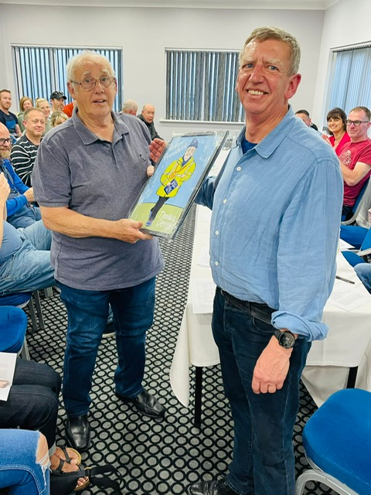

Our sincere thanks to Pete Heath for his several years of leading, as Chair.

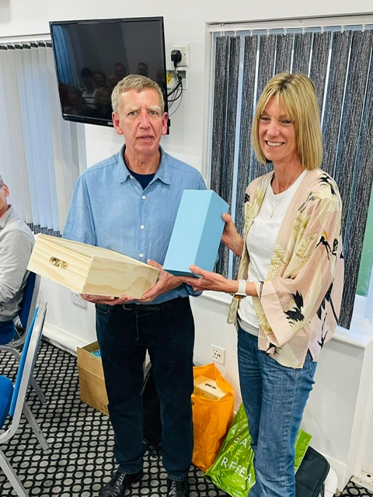

Our great thanks to Kev Bullion, not only for his work as Vice Chair, but for all his support as kit manager.

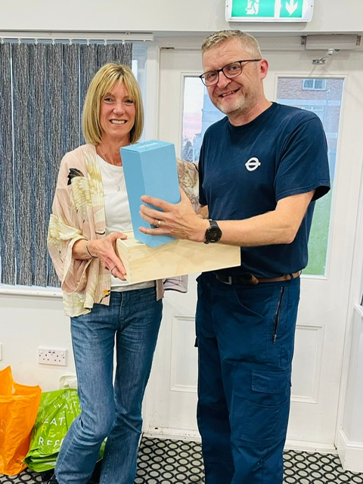

Pete Heath welcomes our new Chair, Julie Neaves and new Vice Chair, Simon Clayton.

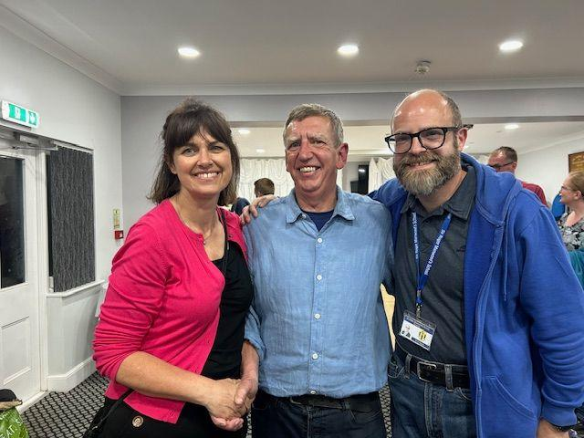

Total attendees = 47 (greatly exceeding the quorum for the meeting, which is 25)

Thanks to all attending!

|  |  |
| --- | --- |
| Members attending: | Committee members present |
|  |  |
| Adam Wade | Ade Neaves |
| Alex Dugard | Andy Stevens |
| Asmaa Hatim | Janice Lee Miller |
| Anna Harrison | Janet Morgan |
| Carly Lines | Jo Kemp |
| Charlotte Barton | Julie Neaves |
| Christopher Brenchley | Julie Williams |
| Chris Pascoe | Kev Bullions |
| Dan Grech | Pete Heath |
| Dave Winch | Simon Cowdery |
| Derek Sackett |  |
| Ela Elzbieta |  |
| Gary Pearse |  |
| Gaynor Shelvey |  |
| Glyn Jenkins |  |
| Ian Lockyer |  |
| Jack Bradley |  |
| James Figgins |  |
| James Newing |  |
| Kirsty McMahon |  |
| Laura Thomas |  |
| Lee Hardie |  |
| Lisa Cook |  |
| Mark Hadden |  |
| Matt McCarthy |  |
| Michelle Gossett |  |
| Nick Gossett |  |
| Pam Philpot |  |
| Pauline Petitt |  |
| Poppy Harris |  |
| Richard Allan |  |
| Robbie Weatherley-Day |  |
| Simon Clayton |  |
| Spencer Hoult |  |
| Stephen Forshaw |  |
| Steve Clarke |  |
| Steve Suttle |  |

[**APPENDIX:**](https://maps.google.co.uk/maps/ms?oe=utf-8&client=firefox-a&ie=UTF8&hl=en&t=h&msa=0&msid=105879619365143952182.000472e993d2fc564c477&ll=51.293405,1.044087&spn=0.016612,0.038238&z=15) Open actions and decisions

|  |  |  |  |
| --- | --- | --- | --- |
| [**ACTION**](https://maps.google.co.uk/maps/ms?oe=utf-8&client=firefox-a&ie=UTF8&hl=en&t=h&msa=0&msid=105879619365143952182.000472e993d2fc564c477&ll=51.293405,1.044087&spn=0.016612,0.038238&z=15) | [**BY WHOM**](https://maps.google.co.uk/maps/ms?oe=utf-8&client=firefox-a&ie=UTF8&hl=en&t=h&msa=0&msid=105879619365143952182.000472e993d2fc564c477&ll=51.293405,1.044087&spn=0.016612,0.038238&z=15) | [**BY WHEN**](https://maps.google.co.uk/maps/ms?oe=utf-8&client=firefox-a&ie=UTF8&hl=en&t=h&msa=0&msid=105879619365143952182.000472e993d2fc564c477&ll=51.293405,1.044087&spn=0.016612,0.038238&z=15) | [**COMMENTS**](https://maps.google.co.uk/maps/ms?oe=utf-8&client=firefox-a&ie=UTF8&hl=en&t=h&msa=0&msid=105879619365143952182.000472e993d2fc564c477&ll=51.293405,1.044087&spn=0.016612,0.038238&z=15) |
| Invite two members to committee meeting  Add reward and recognition as standing item | Julie W | Standing item |  |
| Update role descriptions for circulation | All committee – Julie Wlliams to co-ordinate | April | Only marshal secretary remaining |
| Jon to mail run leaders to ask who would be willing to provide coverage of 11.5 min/mile and ask for volunteer to write a short message on what is involved in being a run leader, and why they would recommend it | Jon | May | Completed via AGM call for volunteers |
| Book venues for upcoming committee meetings, particularly June and July | Julie W | May | In progress |
| Review race leader information | Jon Holl, Julie Williams | March | Alignment with EA being explored |