**TRAC Runner of the month – 2024**

* February – Bathy Beddoes
* March – Adam Wade
* April – Jack Bradley
* May – Sandra Baldock
* June - Mark Croucher
* July
* August
* September
* October
* November
* December

**February – Cathy Beddoes**

Cathy Beddoes has been chosen as Thanet Roadrunners ‘Runner of the Month’ for February 2024. This is a new monthly recognition of a runner, nominated by run leaders and club leaders.

Cathy has thrived as a club runner, having completed Couch to 5k last March, then shortly afterwards experiencing a period of injury & illness that took her out of running until September. She kept herself going by walking until she could come back to us & her return has been amazing. She has gone from strength to strength, completing her first race for TRAC in December (Alan Green 5 mile). She is such a positive ambassador for C25k, but also is chatty, supportive and enthusiastic on every run she is part of. She has recently moved up to Simon's group from the 45 minute run and is thoroughly enjoying increasing her distance and pace (she is running 10 miles at least once a week now). Her love for running is infectious & she is very grateful for having the support and friendship of the club members around her. In particular, the positivity she brought to this years C25K, both as a role model and supporter for some of the participants has been simply outstanding. Cathy epitomises everything Thanet Roadrunners stands for.

#aclubforall #community #runnerofthemonth🏃🏾‍♀️🙌🏾

This a new monthly recognition of a club "Runner of the Month" - someone who has been nominated and selected by our group of run leaders because they have really stood out for their achievement, progress, or their efforts to encourage and support others. A very worthy winner!

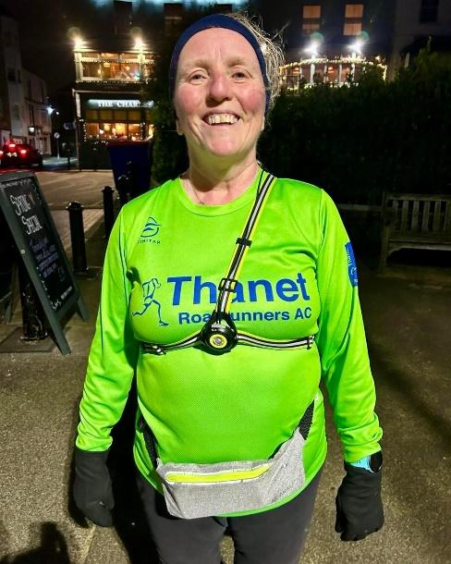

**March – Adam Wade**

Thanet Roadrunners love to celebrate the success of members. ‘Runner of the month’ is someone who has been nominated and selected by our group of run leaders because they have really stood out for their achievement, progress, or their efforts to encourage and support others.

We are delighted to announce that Adam Wade has been nominated by the run leaders this month.

Adam was one of last year's C25K graduates and he has excelled during his first year as a TRAC member. He moved into Simon's group last July/Aug and made excellent progress, encourages other runners and always loops back to support other runners when needed, always with a smile. In November, he achieved his first sub 30 parkrun at Pegwell Bay, and exceeded his expectation by getting a 28:42 PB. Recently, he took the courage to try Elizabeth’s group where he has remained. Many runners fear a move into a faster group, but Adam took it with confidence and is reaping the benefits. Not only is Adam a very capable, solid runner, he is a really nice guy and a pleasure to have in any group.

Many congratulations Adam!!

We asked Adam what attracted him to the club.

His answer was “Laura Thomas, who is a member of TRAC encouraged me to do the C25K in 2023 and when I completed it I decided to join the club and keep the running up. I never looked back.”

Adam says his best moment was completing the C25K and doing his first 10k club run on a Monday evening.

We asked Adam what advice he would give to a new person considering joining. He said “Go for it! As of January 2023 I had never done a run in my life but its amazing what you can do with the right help and all the support from TRAC and Laura Thomas who started me off running. The thing I like most about TRAC is the friendship and support and I always look forward to club runs.”

**April – Jack Bradley**

Thanet Roadrunners love to celebrate the success of members. 'Runner of the month' is someone who has been nominated and selected by our group of run leaders, because they have really stood out for their achievement, progress, or their efforts to encourage and support others. The last two months it’s been awarded to new runners, at the beginning of their journey. This month is rather different… This month, there could only be one winner; JACK BRADLEY.

Jack set out with a target of beating the Thanet Roadrunners club record. To beat a record, in a club which has been sending quality runners to London for over 40 years is no mean task. However, Jack smashed it, with an outstanding time of 2:36:01 to run the 26.2 mile course shaving over 50 seconds from the club record. Not only is Jack an incredibly talented runner, he is also a thoroughly nice guy, who encourages and supports others to help them achieve their dream goals too. This is well deserved Jack.

We asked Jack some questions…

Q. What attracted you to join TRAC?

A. It was 2017 when I joined TRAC. Whilst I have always played one sport or another, it was at this time when I was starting to take running and my training a bit more seriously. I use the word 'seriously' as a loose term, as I still had a lot to learn at that point. I figured that the best place to do that learning was at a running club. TRAC immediately stood out with its well organised training structure - and I can remember that first Monday night like it was yesterday. I was quite nervous, having never been involved with a running or athletics club before. It might sound crazy now, but I didn't even know if I'd be able to keep up! Those fears were quickly put to bed though, as I was welcomed by Steve Clarke and reassured that there was a suitable pace group. I was struck by how friendly and welcoming everyone was; and I quickly felt at home. From that point onwards, there was no looking back.

Q. What’s your best moment?

A. Winning the East Kent Road Relays with TRAC in 2022. There is something about competing in a team that takes things to the next level. That particular year (the most recent edition of the competition), we had a great team. We didn't have the superstars of some other teams; but we were all pretty good. Not only did we work hard, but we were consistent, we showed up for each other and we worked together. We didn't start the competition expecting to even place on the podium, so when we clinched victory at the final meet, it was a very special moment.

Q. What would you say to a new person who is considering joining?

A. Just go for it! I can't think of a more welcoming or supportive environment than the one created by TRAC. Whether you're completely new to running, you're looking to progress your training, or you just want some company for a social run - there is something for everyone.

Q. What does the club mean to you?

A. TRAC feels like a family. We all look out for each other and support each other's goals. Every runner and every achievement is celebrated - and I think that is what makes this club special and a little bit different. The club is a genuine force for good and I am proud to be part of it.

#rolemodel #teamplayer #aclubforall #recordbreaker

**May - Sandra Baldock**

Our May Runner of the month award is all about celebrating the results and achievements of a member who is quietly but consistently putting a lot of effort into their running.

Sandra Baldock has been doing just that – both in club runs and by herself and the results speak for themselves. After regularly joining the Sunday long run (in addition to Monday club run and hills) Sandra entered the Folkestone 10 mile in March, the longest run she had tackled for a few years, and got a pb! She is also steadily improving her parkrun time – could she be a key contender for the club’s new parkrun competition? Sandra has also joined the Thursday track session and in May achieved yet another pb at the Whitstable 10K race. We are all so impressed with seeing how Sandra’s hard work and consistent training are strengthening her abilities as a runner – well done from all of us!

We asked Sandra our usual questions:

Q. What attracted you to join TRAC?

A. I joined the C25K programme in January 2020, as an alternative to the gym. I'd never run before so was a complete novice.

Q. What’s your best moment?

A. My best moment was completing the C25K and doing the graduation parkrun with the club. A week after we went into covid lockdown, but I carried on running on my own or with the support of Maryanne Aitken when allowed with 1 other.

Q. What would you say to a new person who is considering joining?

A. I would tell them to go for it, because whether new to running or a more experienced runner there is always a supportive group to suit all abilities. Everyone is encouraging and friendly.

Q. What does the club mean to you?

A. The club means I have a great group of friends to run with and socialise with at club events like BBQ runs, quiz nights as well as outside of running.

**June - Mark Croucher**

Our June Runner of the month award is all about celebrating the results and achievements of a member who is quietly but consistently improving his running and representing us at a large number of races.

MARK CROUCHER (pictured at our Harbour Wallbanger Beach Race) has been nominated by the club’s run leaders for doing just that. He is a great team player and the results speak for themselves.

Mark doesn’t drive, but still gets to many of our training sessions and has been making the best of Sunday morning long runs, when he’s not competing.

From competing recently, Mark is currently second in the our club championship and has contributed to a very high amount of points in the Grand Prix for TRAC. His father, Victor, has been supportive in Mark’s recent achievements and has cheered us all on at the races

Mark is a friendly and positive member of the club whose hard work is now paying off with some excellent race results. As a club, you make us proud Mark!

Here are some thoughts from Mark:

Q: What attracted you to join TRAC?

A - I have Lainey Carter Mua to thank for introducing me to Thanet Roadrunners. She completed Couch to 5k in 2023 and was full of enthusiasm for running and the club.

Q: What’s your best moment?

A - Every time I run a race wearing my Thanet Roadrunners vest I feel proud to be representing the club. 10k is my favourite distance. I’m enjoying competing in the Club Championships this year.

Q: What would you say to a new person who is considering joining?

A – I would tell them what a friendly club it is. I don’t drive but people help me with lifts whenever they can. I love running as part of a team.

Q: What does the club mean to you?

A - The club means I have a great group of friends to run with and socialise with at club events like the BBQ run which I enjoyed last week. I used to go off too fast in races, but people in the club have given me tips which have really helped my running. I love being a roadrunner!

